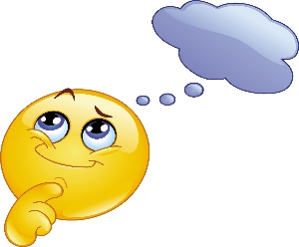
Alcohol Learning Target Review
This Photo by Unknown Author is licensed under CC BY-SA-NC
Learning Target Show what you know..
4 Short Term effects of alcohol use | 1.  2.  3.  4.
4 Long Term effects of alcohol abuse | 1.  2  3  4
What is the difference between alcohol use and abuse?
How can genetics and family history pre-dispose an individual to addiction issues?
How does alcohol effect decision making skills? Give 2 examples
What types of unhealth and risky behaviors might result from alcohol use?
Describe 2 refusal strategies you can use to resist pressures to use alcohol.

