Obesity Trends in America

Power point – CDC’s obesity rates

- Describe the change that is occurring among obesity and overweight rates among Americans.

- Why do you think Americans are becoming more and more overweight?

- Factors causing increased occurrence of overweight:

  - Unhealthy ______________
    - Examples:

  - Portion sizes -

  - Drinks -

  - Activity –

- Describe 2 initiatives in our local community that are helping to reduce overall obesity and overweight rates?

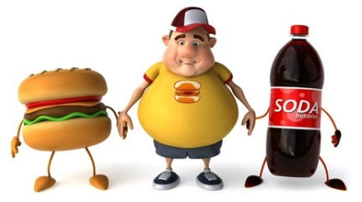
- Do you think the government has the right to dictate what kinds of foods can be served in school cafeterias and vending machines? WHY?

