PICKELBALL
Pickleball is the fastest growing sport in the United States. Known for its ease of learning and appeal to all ages. Pickleball combines elements of________________, _________________ and _____________________. It is played on a court the size of a Badminton court, with a low net similar to Tennis, and with what looks like an oversized ping pong paddle and a __________________ball.

HISTORY
Pickleball was invented in__________________ during the summer of 1965 by two men that found their families sitting around with nothing to do while on vacation. Their property had an old badminton court so they looked for some badminton equipment and could not find a full set of rackets. They improvised and started playing with ping-pong paddles and a perforated plastic ball.
According to one of the inventors, the game was officially named after a family dog, ____________________, who would chase the ball and run off with it.

THE COURT
Pickleball is played on a rectangular 44’ by 20’ court. The court is divided into two sides by a low net.
There are two sidelines, two baselines, a ___________________ on each side, as well as two _______________________, which creates an area called the “_______________” in Pickleball.
The center line divides each side into two service courts, the left service court and the right service court. This allows players to know where to serve the ball and where to stand when serving.
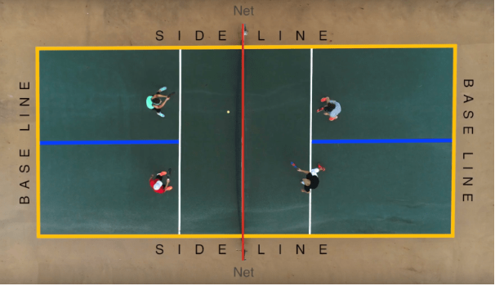
RULES & REGULATIONS
The start of a game begins with a serve. The player standing in the ____________ service court is always the first server, whether at the beginning of a game or on a side-out. Before serving the server ______________ call the score.
A Pickleball serve must be hit underhanded from behind the baseline cross court into the opposing team’s service court. The serve must clear the net and _________ land in the kitchen.
Players may not hit the ball while standing in the _______________unless the ball has already bounced on their side. Players may __________step into the kitchen to volley the Pickleball. Players may not enter the kitchen on a ________________ even if their momentum carries them into the zone.
An important rule in Pickleball is the ______________________ rule. The double bounce rule says the ball must bounce once on each side before either team may start volleying the ball in the air.

MATCHES/SCORING
Matches are played best two games out of three. Each game is played to ________points, win by two. Or if you are playing one game, it is played to fifteen points, win by two.
Only the_______________ team can score a point by winning a rally.
The player in the right service court will always serve first for a team. If the serving team scores a point, the two players switch places, so the first server now serves from the left service court. The serving team will continue switching places until they lose a rally. When the serving team _____________a rally, the ________________________now serves from his current position.
Once the serving team loses another rally, the opposing team now has two chances to serve. This is called a ________________________.

