SHUFFLEBOARD
OBJECTIVE:
The game of shuffleboard is played by: two (2) persons (called _____________), or by four (4) persons (called __________________).
The object of the game is to propel _____________ by means of a ___________ on to a scoring diagram at the opposite end of the court--to score, to _____________ opponent from scoring, or both.
HISTORY:
The game was first called __________________and later shovelboard. It seems to have originated in England, where there is a record of its being played in 1532, and in its earliest form consisted of shoving ___________ across a polished tabletop (_________________) as a past time for royalty. The game would become so popular with the masses that people stopped going to work, causing it to be banned.
Shuffleboard first came to the United States around the time of the Civil War and grew during the late 1800s and early 1900s. In modern times, a modified form of the old indoor game became popular among travelers on ocean liners and cruise ships as a __________ game. For the shipboard version, called shuffleboard, courts of various designs were marked on the deck, with lined sections at either end.
Shuffleboard was introduced about 1913 at ___________________, _____________, as a game on land. The game was so popular that it spread rapidly through the United States, particularly in __________________ communities, with each community devising its own rules of play. The modern form of shuffleboard was defined at St. Petersburg, Florida, in 1924.

RULES AND REGULATIONS:
To start a game, the yellow (light-colored) disc is shot first. Play alternates yellow (light) then black until all discs are shot. Yellow (_________) shall always be played from ____________ side of the __________ of court, and ____________ side of ___________ of court.
Players shall not stand in the way of, or have a cue in the way of, or interfere with any other players at any time.
Any player ______________ two (2) ____________________ discs, _______________: 10-Off, plus any 10-Offs the offender may have on the court.
Any disc that clearly leaves the court beyond the farthest baseline or goes off the sides of the court is a ______________ disc.
A disc which stops less than eight (8) inches beyond the farthest baseline shall be _______________.
A disc that is leaning over the edge of the court and touching the _______________shall be immediately removed.

SCORING:
The scoring diagram consists of one _____-point area, two ____-point areas, two _____-point areas and one ___________ area. _______ both players have shot their four (4) discs, score all the discs on the diagram _________ and _________ touching the lines. The separation ______________ in the 10-Off area is not considered.
Play continues until _______ discs have been shot in a half-round, even if the game has been reached. If a tie game results at the game point or over, play is continued in regular rotation of play, until two full rounds in Doubles or one full round in Singles is _______________. At that time the side with the higher score wins, even if it has less than the number of points specified as game point. If the score is tied again, play continues again as outlined.
Games may be played to _______ ,________, or _________ points, as players desire. To count, disk must be ______________ within scoring sections, clearing all lines.
In match play (best 2 out of 3), the second game is started with a black disc.
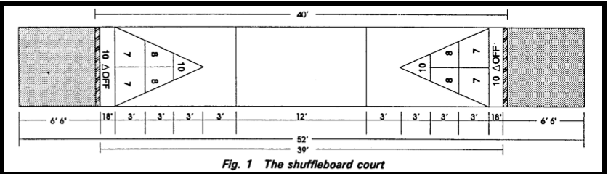

EQUIPMENT:
Four (4) discs shall be colored yellow, four (4) colored black. These eight (8) discs comprise a set. Other colored combinations may be used, such as white, red, blue, etc., as long as there are two (2) ____________________ colors.
The ___________ shall not have an overall length of more than six feet 3 inches (6’3”).

TERMINOLOGY:
Cue – Also called a shuffleboard stick, this is a device used to shoot the discs in outdoor/______________ shuffleboard.
_________ – These are the playing pieces you use in outdoor shuffleboard in place of _____________.
___________ – A head in outdoor shuffleboard is slang for the end of the court that has the scoreboard. This is the side of the court from where all games should __________
Hammer – A hammer shot is the __________ shot of the round.

