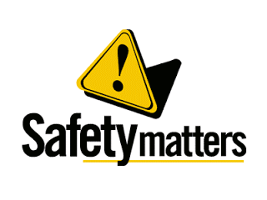
Sport Safety Commissioners

Name: Partner:

You and your partner are Sport Safety Commissioners. Pick a specific exercise activity or sport. Develop safety guidelines with regards to training, clothing, and gear for an individual participating in that sport.

Activity / sport:

Safety Risk | Guideline to offset risk
1.
2.
3.
4.
5.
6.
7.

Summary paragraph explaining how to participate safely in this activity.
